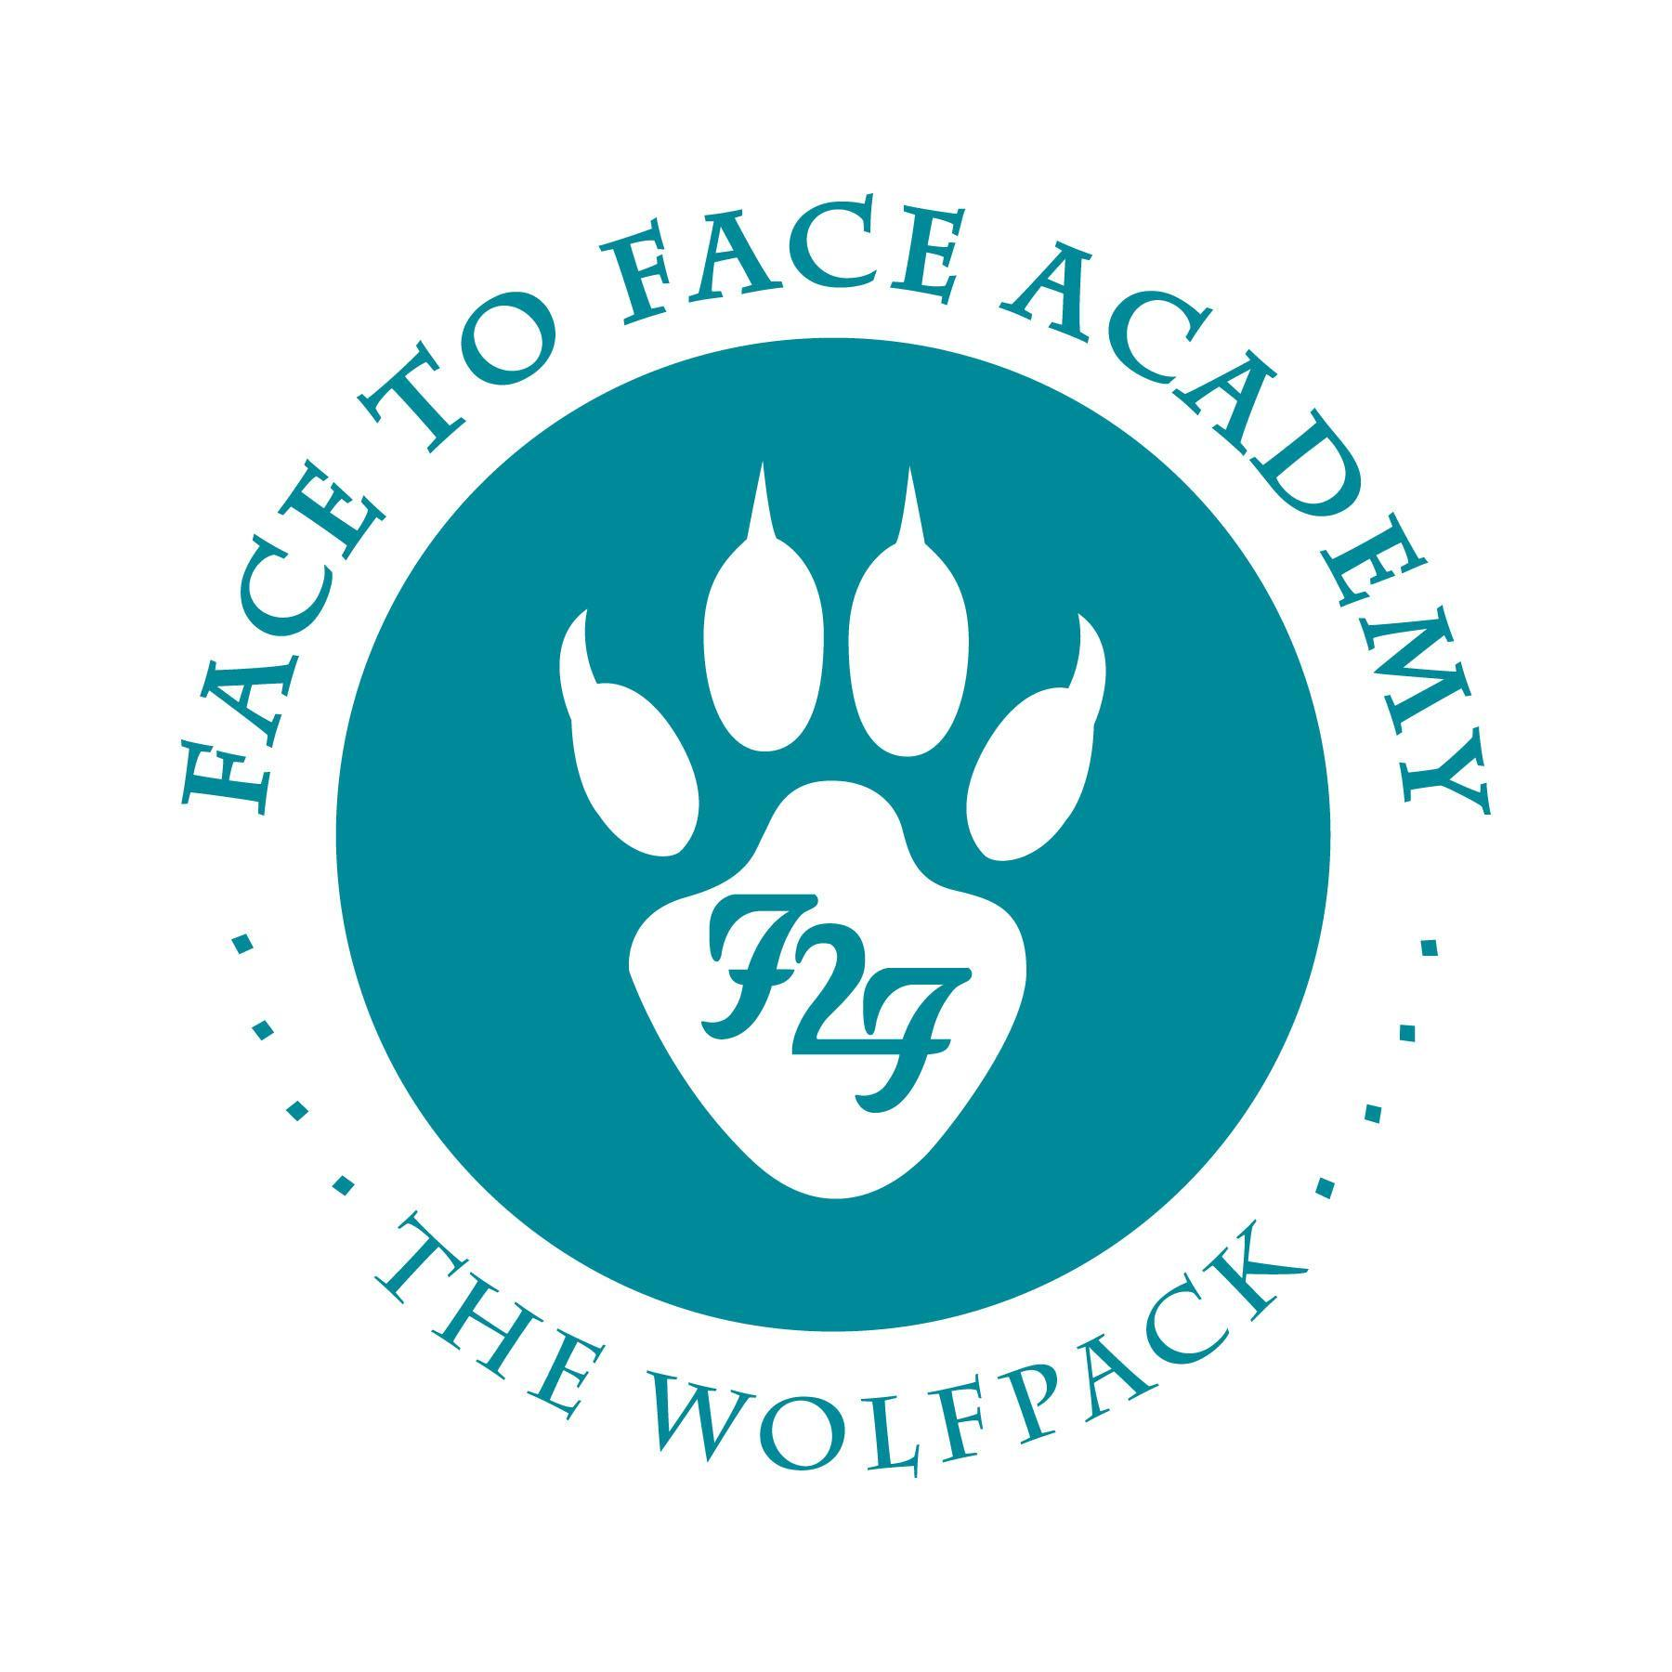
Face to Face Academy

Board Meeting Notes

April 19, 2021

Attendance included Academy School Board Members Bryan Bakke, Mike Nord, Paul Roark, John Vasecka, Arin Hooker, Rachael Blawat, and Willie Suttle. Also present for the meeting were Darius Husain (Academy Director,) Jennifer Plum (Assistant to the Board Secretary,) Tom Kigin (Advisor to the Board Members,) and Joe Aliperto (Deici.) This Board Meeting was conducted via Zoom Meeting with all attendees online due to the restrictions in place for COVID-19.

1) Review of Agenda and Conflict of Interest Regarding Agenda Items
No conflicts were noted.

2) Review of Board Minutes March 2021

Upon a motion duly made and seconded, the March 15, 2021 School Board Minutes were accepted as submitted.

3) Finance Report, Credit Card, Checks, and Wire Statements presented by Mr. Husain
- Financial Statements were received through 03/31/21 for school year 2020/21 and shared for the Board to review.
- Revenue is at 70% received.
- Expenditures are 70% spent.
- School year is 75% complete.
- ADM is on target for 85 students, but the budget has been updated to reflect properly the current ADM of 95 students. The higher enrollment is possible during a hybrid or distance-only model.
- Reconciled cash balance is indicated on the financial document at $613,790.
- Current total state holdback is noted at $119,458 which is 10%.
- Donations are on pace and received at $21,169.
- The fund balance is currently predicted at 45-50%.
- Federal funding is always on a lag in comparison to other funding streams.
- Title funding begins as soon as the application is finalized.
- Review of the additional federal revenue related to Covid. The ESSER funds will be discussed later.
- Special Education is over-budgeted with the higher population and services provided. These expenditures are reimbursable at 95%.
- The food service (fund 2) continues to provide bulk items for school lunches and breakfasts that can also be delivered to student homes. The Academy is currently feeding less students a day during the hybrid and distance-only programming. Less families are requesting the food supplies. There is not an anticipated transfer from the general fund to the food service fund this school year.
- More students are using the city buses again causing a need for more tokens and cards.
- The recent Amazon purchases were shown to the Board members.

Check and credit card statements and the wire transfers were circulated for review.
- Dave Boquist provides services to the school including painting, building maintenance, and music instruction.

Upon a motion duly made and seconded, the financial, credit card, check and wire statements were accepted as submitted.

4) Professional Development: School Staff Compensation Report
- Budget Survey document from the Minnesota Association of Charter Schools (MACS) was shared with the Board Members for discussion.
- Analysis of how Face to Face Academy salaries compares to the MACS survey of charter school salaries.
- Discussion of how Academy salaries are in comparison to St. Paul Public Schools.

5) SY 2022 Budget First Look
- Salaries include a 3% increase for cost of living with some other adjustments based on the recent salary surveys and in order to remain competitive. Increase adjustments include Q Comp performance pay.
- Mr. Kigin noted that Board Members may want to view salary adjustments in more detail.
- Discussion about how to have conversations about individual salaries when the Academy staff is small and teachers are on Board.
- Agreement was to hold an Executive Committee of Board Members to review staff compensation in addition to the annual review of the Program Director and approval of the Academic Director’s performance pay. Mr. Nord and Mr. Husain will set up time for the Committee to meet.
- Budget is projected with a 87 ADM.
- Discussion of the increase of ESSER Funds 1 & 2. Each fund has guidelines on what purchases can be covered.
- Health care costs are assumed a 10% increase.
- Kinney Family Foundation fund will continue next year.
- Budget includes a surplus of $46K, closer to a fund balance of 50%.

Upon a motion duly made and seconded, the SY 2022 budget was accepted as submitted with the recommendations from the Executive Committee to be given at next Board Meeting. Roll Call noting approval include: Mr. Nord, Mr. Bakke, Mr. Vasecka, Mr. Suttle, and Mr. Roark, Ms. Blawat, and Ms. Hooker.

6) Equitable Access Learning Model: Continued flexibility in accessing instruction for SY 2022 and beyond
- Equitable Access Learning Model Overview was shared with Board Members for discussion.
- The three different tiers were shared to describe the categories of students who may use this platform of the Academy program.
- The Academy team and Molly McGraw Healy have already reviewed this model. UST has requested that the current contract template include this Learning Model.
- Implementation of the Equitable Access Learning Model would be piloted in school year 2021/22.
- Discussion of how the daily schedule and delivery of instruction would address the students on different schedules.

Upon a motion duly made and seconded, the language of the Equitable Access Learning Model to be used in the UST contract template was accepted as submitted.

7) Building Renovation: Update and Proposal Plan
- Board voted previously to use surplus from this school year to cover renovations to the classroom spaces.
- Two different companies, J Vang and Flannery, have made recommendations to the Academy’s space.
- Mr. Suttle has also been involved in the bidding and design process.
- Renovation would create a new classroom in order to keep class sizes small and maintain social distancing.
- Discussion of the redesign options.
- Bids are expected this week.
- Classrooms need to be ready by July when students return to campus.
- Funding would come from the current surplus and potentially ESSER funding.
- Board Members agree to move forward in the renovation process.

8) Vaccination Opportunity for Students and Families
- Students 16 and older and their families in certain zip codes can now access the vaccines at the mass site at the state fairgrounds. Many Academy families live in these approved zip codes.
- Academy staff have shared this information with students and families.

9) Academy Program Report

- The Academy has reserved the Como Lakeside Pavilion for the June graduation. It is a large outdoor venue that meets all Covid protocols in place for large group gatherings outlined by the state.
- There are nine projected graduates.
- Discussion about how to support students and community safety in light of the anticipated verdict in the Chavin trial.
- Next Board Meeting may need to be pushed back a week.

Meeting adjourned at 6:00 p.m.
Respectfully Submitted,

Bryan Bakke
Board Secretary

