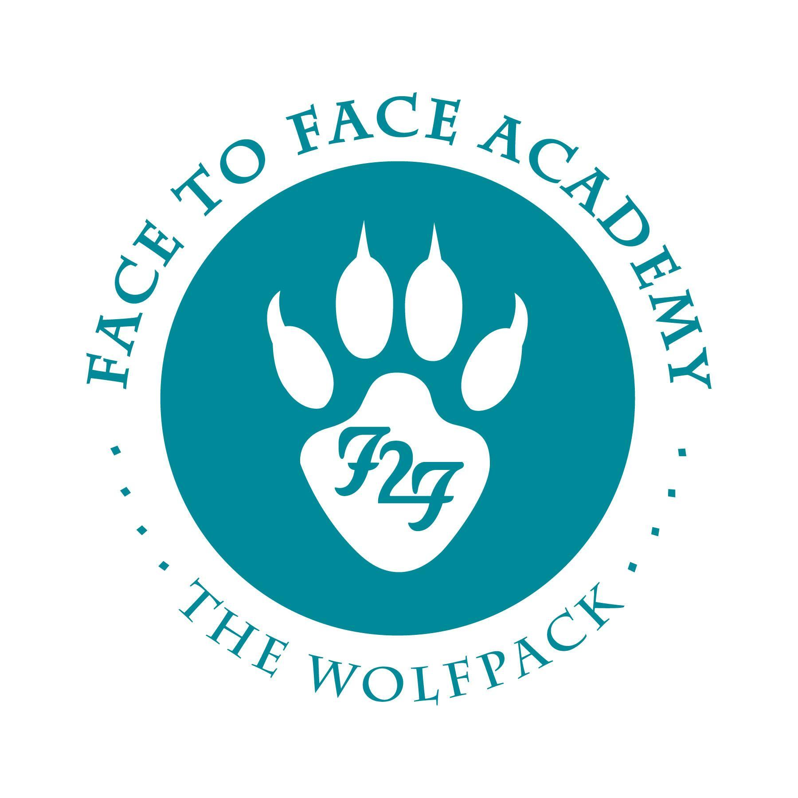
Face to Face Academy

Board Meeting Notes

February 22, 2021

Attendance included Academy School Board Members Bryan Bakke, Mike Nord, Paul Roark, Arin Hooker, John Vasecka, and Willie Suttle. Also present for the meeting were Darius Husain (Academy Director,) Jennifer Plum (Assistant to the Board Secretary,) and Tom Kigin (Advisor to the Board.) This Board Meeting was conducted via Zoom Meeting with all attendees online due to the restrictions in place for COVID-19. Absent: Board Member Rachael Blawat.

1) Review of Agenda and Conflict of Interest Regarding Agenda Items
No conflicts were noted.

2) Review of Board Minutes January 2021

Upon a motion duly made and seconded, the January 25, 2021 School Board Minutes were accepted as submitted.

3) Finance Report, Credit Card, Checks, and Wire Statements presented by Mr. Husain
- Financial Statements were received through 01/31/21 for school year 2020/21 and shared for the Board to review.
- Revenue is at 58% received.
- Expenditures are 54% spent.
- School year is 58% complete.
- ADM is on target for 85 students. The current ADM above 95 students. The higher enrollment is possible during a hybrid or distance-only model.
- Reconciled cash balance is indicated on the financial document at $640,929.
- Current total state holdback is noted at $87,379 which is 10%.
- The fund balance is currently predicted at 45-50%. The current fund balance Board policy is written at 30-35%. Discussion about the Board’s options with the fund balance and recommendation that the policy is reviewed in the upcoming months.
- Mr. Husain and Mr. Aliperto have gone through another budget revision.
- Discussion of how Western Bank has pledged additional securities for all FDIC requirements and state statutes.
- Federal funding is always on a lag in comparison to other funding streams.
- Review of the additional federal revenue related to Covid.
- Donations are on pace as budgeted.
- Health benefits are paid one month in advance.
- Purchase surfaces may run over-budgeted due to expenditures attributed to some Special Education services that are not covered under current staff member’s licenses like Speech/Language and Autism.
- The Academy’s budget and fund balance is healthy during these unprecedented times.
- The food service continues to provide bulk items for school lunches and breakfasts that can also be delivered to student homes. The Academy is currently feeding less students a day during the hybrid and distance-only programming. Less families are requesting the food supplies.
- The recent Amazon purchases were shown to the Board members.

Check and credit card statements and the wire transfers were circulated for review.
- The charge to Selby Acupuncture was an accidental transaction and has been corrected.
- Blackbaud refers to the fundraising platform membership.
- Jennell Lopez refers to Academy graduate tuition reimbursement.

Upon a motion duly made and seconded, the financial, credit card, check and wire statements were accepted as submitted.

4) Timetables for SY 2021 Budget Revision and 1st Draft of SY 2022 Budget
- The budget revision for SY 2021 will be ready for the March Board meeting.
- The SY 2022 budget will be ready for the Board to review after the legislative session, either April or May 2021.

5) Executive Action Returning Secondary Students to In-Person Learning: Relevant Details & Academy Response
- Document was shared for review summarizing the Academy’s response to the Executive Action from the Governor.
- With the Academy currently in Hybrid instruction, many of these recommendations have already been implemented.
- Discussion of Covid testing for staff and the community opportunities for free testing for students and families. Schools are currently supplied for enough tests for on campus testing for staff only.
- Although current state recommendations ask for social distancing of a minimum of three feet, the Academy is able to provide six feet of distance for staff and students.
- The new recommendations require documentation of seating arrangements when students eat on campus (indoors) in case of the need for contact tracing.
- Academy students are able to move back and forth between on campus or distance learning instruction at any time.
- The Academy recommends building more opportunities for students to be on campus within the Hybrid model for the remainder of the 2020/21 school year.
- Discussion of how the Academy can collect data on Covid vaccination.

Upon a motion duly made and seconded, the Academy’s Final Recommendations noted in the Response to the Executive Action were accepted as submitted. Roll call for approval including Mr. Suttle, Mr. Vasecka, Mr. Roark, Mr. Nord, Mr. Bakke, and Ms. Hooker.

6) Vaccination for Teaching & Support Staff Update
- Discussion of the state’s process of vaccinating educators and the Academy’s response.
- The State of Minnesota has allotted 10 vaccines for the Academy’s 13 full time and 3 contractual staff members.
- The Academy created a tier system about how staff members would qualify for the vaccines.
- Governor has a goal of offering all educators an opportunity to be vaccinated by March 8th.

7) High Quality Charter School Designation for SY 2021
- Face to Face Academy was designated as a High Quality Charter School for SY 2021.
- Only 14 Minnesota charter schools qualified for this distinction.

8) Professional Development: Legislative Update, Charter School Day at the Capital, and Board Advocacy
Postponed until the next Board meeting.

9) Academy Annual Report for 2019/20
- The Highlights of SY 2020 from the Annual Report were reviewed.
- Due to the state-mandated school closing due to Covid in Spring 2020, there is no reportable test data.
- Review of the other academic goals.
- Review of the Finances on the Annual Report.

Upon a motion duly made and seconded, the Academy’s Annual Report for 2019/20 was accepted as submitted.

10) Program Report
- The Academy currently finished its first week of Hybrid instruction. The student population appears to be accessing the program equally on campus and distance only. Some of the hesitance to the return to campus may be cold weather related.
- The UST 5-year contract renewal virtual visit was a success and the UST review members reported positive feedback about the program and its distance learning instruction.
- The December graduation tribute video celebrating 10 students was released on youtube on January 29th.

Meeting adjourned at 5:45 p.m.
Respectfully Submitted,

Bryan Bakke
Board Secretary

