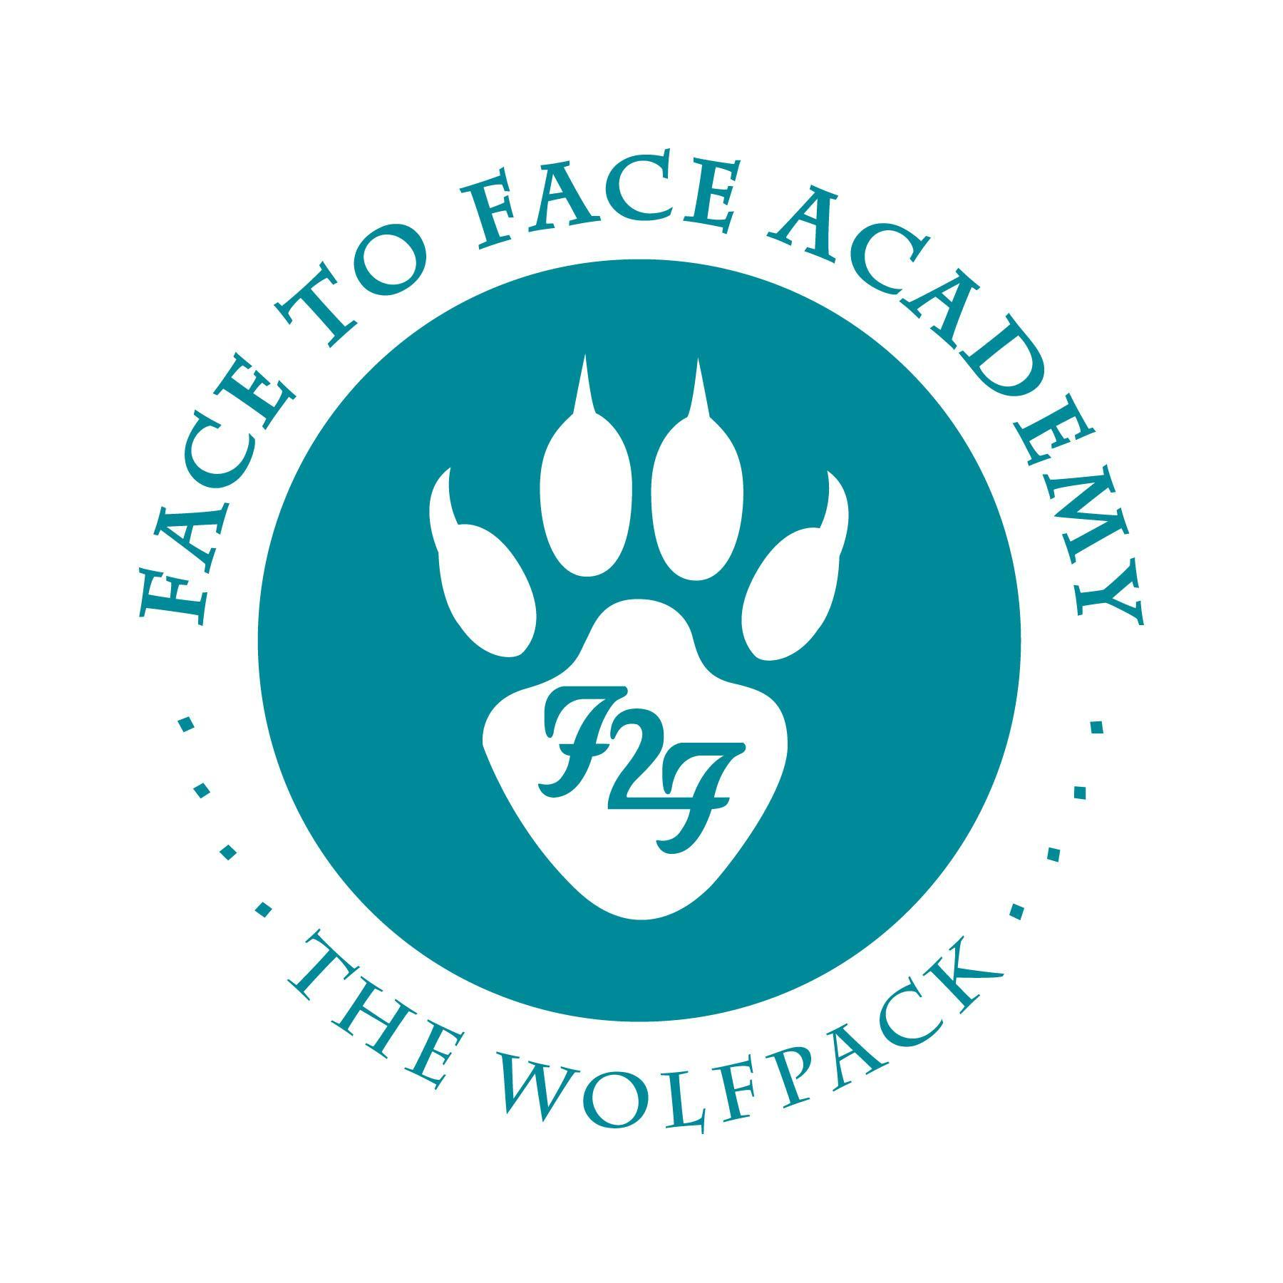
Face to Face Academy

Board Meeting Notes

July 8, 2021

Attendance included Academy School Board Members Bryan Bakke, Mike Nord, Rachael Blawat, and Willie Suttle. Also present for the meeting were Darius Husain (Academy Director,) Jennifer Plum (Assistant to the Board Secretary,) Tom Kigin (Advisor to the Board Members.) This Board Meeting was conducted both on campus and via Zoom so that all attendees could attend. Absent: Board Members Paul Roark, John Vasecka, and Arin Hooker.

1) Review of Agenda and Conflict of Interest Regarding Agenda Items
Discussion of the recent financial statements and Board Members agreed to postpone this topic to the next meeting.

The Executive and Academic Directors review will be moved to the last agenda item and both individuals will excuse themselves from the Board Meeting during this discussion.

2) Review of Board Minutes May 2021

Upon a motion duly made and seconded, the May 24, 2021 School Board Minutes were accepted as submitted.

3) Finance Report, Credit Card, Checks, and Wire Statements were postponed.

- Financials will be shared at the next Board meeting. A brief summary of the year-end was presented by Mr. Husain.
- For school year 2020-21, the ADM reported by MDE is 93.5 and the internal Academy ADM is closer to 94+. Reconciliation is currently in process.
- Review of ESSER funding streams and how it connects to the budget surplus and the current renovation project. Review of the qualifications of the ESSER funds.

4) Board Calendar for SY 2022

- Board calendar draft was shared and discussed.
- Next Board Meeting will be held on Thursday, August 19, 2021.
- Discussion of how to proceed with attendance expectations of Board Members either in person or via Zoom. The Board Meeting today is held both openly on campus and with members attending remotely. The State of Minnesota needs to issue guidance on school board attendance expectations in regard to Covid.

Upon a motion duly made and seconded, the Board calendar of meetings was accepted as submitted.

5) Safety Protocols & COVID mitigation Strategies for Summer Session
- Review of the Academy staff discussion of safety protocols for the re-opening of the school for SY 2022 in July.
- There is currently no guidance for SY 2022. Summer school guidance has been issued with safety protocols remaining in place with the official language changing from “required” to “strongly recommended.” For example, masks/face coverings were formally “required” and now the guidance “strongly recommends” mask-wearing.
- The Academy team recommends increasing the class pod sizes from 9 to 12 students and allowing staff members to share office spaces.
- The Academy team also recommends that masks/face coverings continue to be worn by all community members while indoors during the school day and with students. Social distancing is recommended inside during the school day. Finally, vaccinated staff members may be unmasked while there are no students in the building.

Upon a motion duly made and seconded, the summer Covid mitigation strategies were accepted as submitted.

6) Liability Coverage: A Primer of what is currently offered & additional options
- Review of the liability coverage policies.
- The insurance provider mentioned that schools typically have a specific Sexual Abuse and Molestation (SAM) policy. Mr. Husain researched this type of policy and read through sample policies. A SAM policy sample was shared with Board Members.
- The insurance provider also stated that the Academy’s current policies on violence and sexualy harassment do not fully outline material for full insurance in these areas.
- Discussion of the language of the policy and some sample scenarios like transportation of students.
- Board suggestion to adopt the policy in order to fulfill insurance deadline purposes with the intent of reviewing/revising the policy.
- Board suggestion possibly getting support in revising the policy.
- Board members feel uncomfortable passing policy without the full review and input of Academy staff members and would like to revisit the topic in the next Board meeting.

Upon a motion duly made and seconded, the current SAM policy was accepted as submitted with the intent that a full review with Academy staff and Board members occurs. Role call approval noted from Mr. Bakke, Mr. Subtle, Mr. Nord, and Ms. Blawat.

7) COVID Safety Protocols: Mask Policy, Vaccinations, Student Saliva Testing
These topics were discussed previously in the meeting.

8) Building Renovation Update

- Mr. Husain outlined the updates and the process of the renovation of each area. Permits delayed the process a week and final approval of the construction will occur next week.
- The start of the first week of school is modified in order for the construction to be completed before all students are on campus.
- Mr. Husain was able to provide a visual tour of the changes.
- The pantry and the partition wall will be completed in phase two of the renovation. The classrooms were the priority in order to re-open campus.

9) Academy Program Report

- SY 2022 starts on Monday, July 12th. The first week will be modified in order for construction to be completed.
- Students are returning to full in-person instruction while some students will begin to participate through the Equitable Access Learning Option (EALO.)
- The biggest challenge for the upcoming contact period is supporting students as they return to full time daily attendance.
- The Board’s Executive Committee scheduled to meet in order to review staff salaries.

10) Executive Director Review Approval and Statement on Academic Director Review

- Mr. Husain and Ms. Plum exited the Board meeting.
- Board discussed the evaluation of the Executive Director position.
- Scores from the staff evaluations were presented.
- The interview process was discussed and a summary was circulated for discussion.
- A recommendation of 100% rating was given.

Upon a motion duly made and seconded, the recommendation of the Executive Director Committee was accepted as submitted. Role call indicating approval: Mr. Bakke, Ms. Blawat, and Mr. Nord.

Mr. Bakke made the recommendation for Jennifer Plum to receive full compensation of the Academic Director Q-Comp Performance Incentive.

Upon a motion duly made and seconded, the Academic Director’s recommendation for Q- Comp incentive pay was accepted as submitted.

Meeting adjourned at 5:58 p.m.
Respectfully Submitted,

Bryan Bakke
Board Secretary

