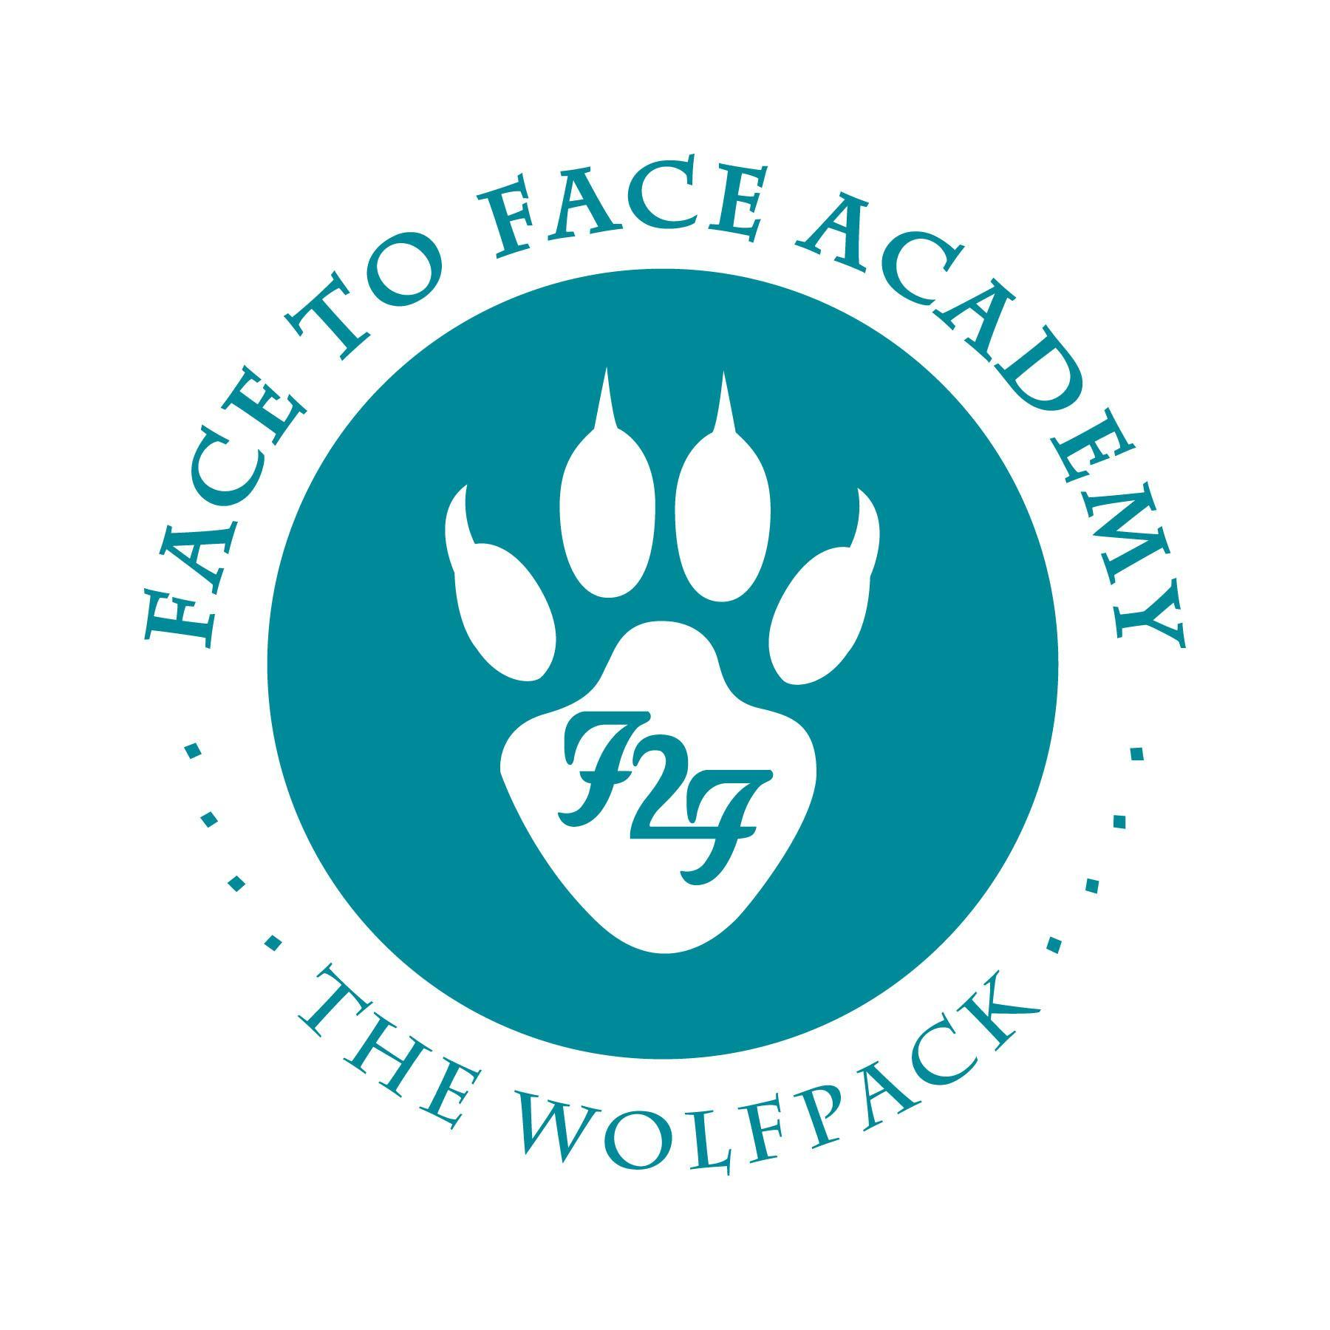
Face to Face Academy

Board Meeting Notes

October 17, 2022

Attendance included Academy School Board Members Bryan Bakke, Mike Nord, Rachael Blawat, John Vasecka, Paul Roark, Margo Thomas, and Willie Suttle. Also present for the meeting was Darius Husain (Academy Director.) This Board Meeting was conducted both on campus and via Zoom so that all attendees could attend.

1) Review of Agenda and Conflict of Interest Regarding Agenda Items
No conflicts were noted.
Additional agenda item: site visit and meeting with the Academy’s authorizer.

2) Review of the Board Election

Upon a motion duly made and seconded, the Board election certification was accepted as submitted.

3) Review of Board Minutes September 2022

Upon a motion duly made and seconded, the September 19, 2022 School Board Minutes were accepted as submitted.

4) Finance Report, Credit Card, Checks, and Wire Statements
- Financial Statements were received through September for the school year 2022/23 and shared for the Board to review.
- Revenue is at 23% received.
- Expenditures are 21% spent.
- The school year is 25% complete.
- Reconciled cash balance is $640,650.
- Holdback is noted at $36,649.
- Donations received are at $2,762.
- ADM is targeted at 89. Enrollment is climbing to 93 students in the second quarter.
- Lease aide should begin to be received now that the application has been submitted.
- Federal funding typically begins to be received in the spring.
- The Kinney Grant for this school year has been received.
- Checks and wires, Amazon purchases, and the credit card statements were circulated for the Board members for review.

Upon a motion duly made and seconded, the financial documents were accepted as submitted. Role call approval noted from Mr. Bakke, Mr. Suttle, Mr. Nord, Mr. Vasecka, Ms. Thomas, Mr. Roark, and Ms. Blawat.

5) Annual Charter School Statement of Assurances
- Forms were circulated for the Board Chair to sign in order to submit.
- Forms include the Annual Charter School Assurances.

6) Review of the Annual Report
- The Annual Report for the school year 2021-22 was shared for review.
- Board discussion included discussion of the Highlights, school attrition trends, academic goals, post secondary goals, and the parent satisfaction survey.
- The Annual report is posted on the Academy’s website, reported to the Academy’s authorizer, and the assurance of the report is submitted to MDE.

Upon a motion duly made and seconded, the Annual Report for SY22 was accepted as submitted.

7) Board Development - Four Strategic Areas of Growth
- Review of the four areas of the strategic areas of growth.
- The first area of focus is post-secondary success for students including ongoing development of the Work-Based Learning Program, creating an alumni database of post secondary success, and the ongoing development of Senior Seminar.
- Second area of focus is the Equitable Learning Access Model to allow online learning options for all students.
- The third area of focus is on the creation of the ABC and evaluating the overall quality of facilities of the Academy.
- The fourth area of focus is keeping the staff salaries competitive.

8) Academy Program Report

- Enrollment is noted at 92 students with several new ones beginning in the second quarter.
- In-person, on campus attendance is averaging closer to 45 students.
- The authorizer site visit with St. Thomas occurred last week and included classroom observations, student and parent meetings, and staff interviews.
- Mr. Suttle noted the Board Member interview.
- Discussion about the “level green” Covid protocol. Most students have stopped wearing masks while most staff members continue to wear masks.
- Board Members to attend the meeting on site for November 21 is Paul Roark & John Vasecka.

Meeting adjourned at 5:30 p.m.

Respectfully Submitted,

Bryan Bakke
Board Secretary

