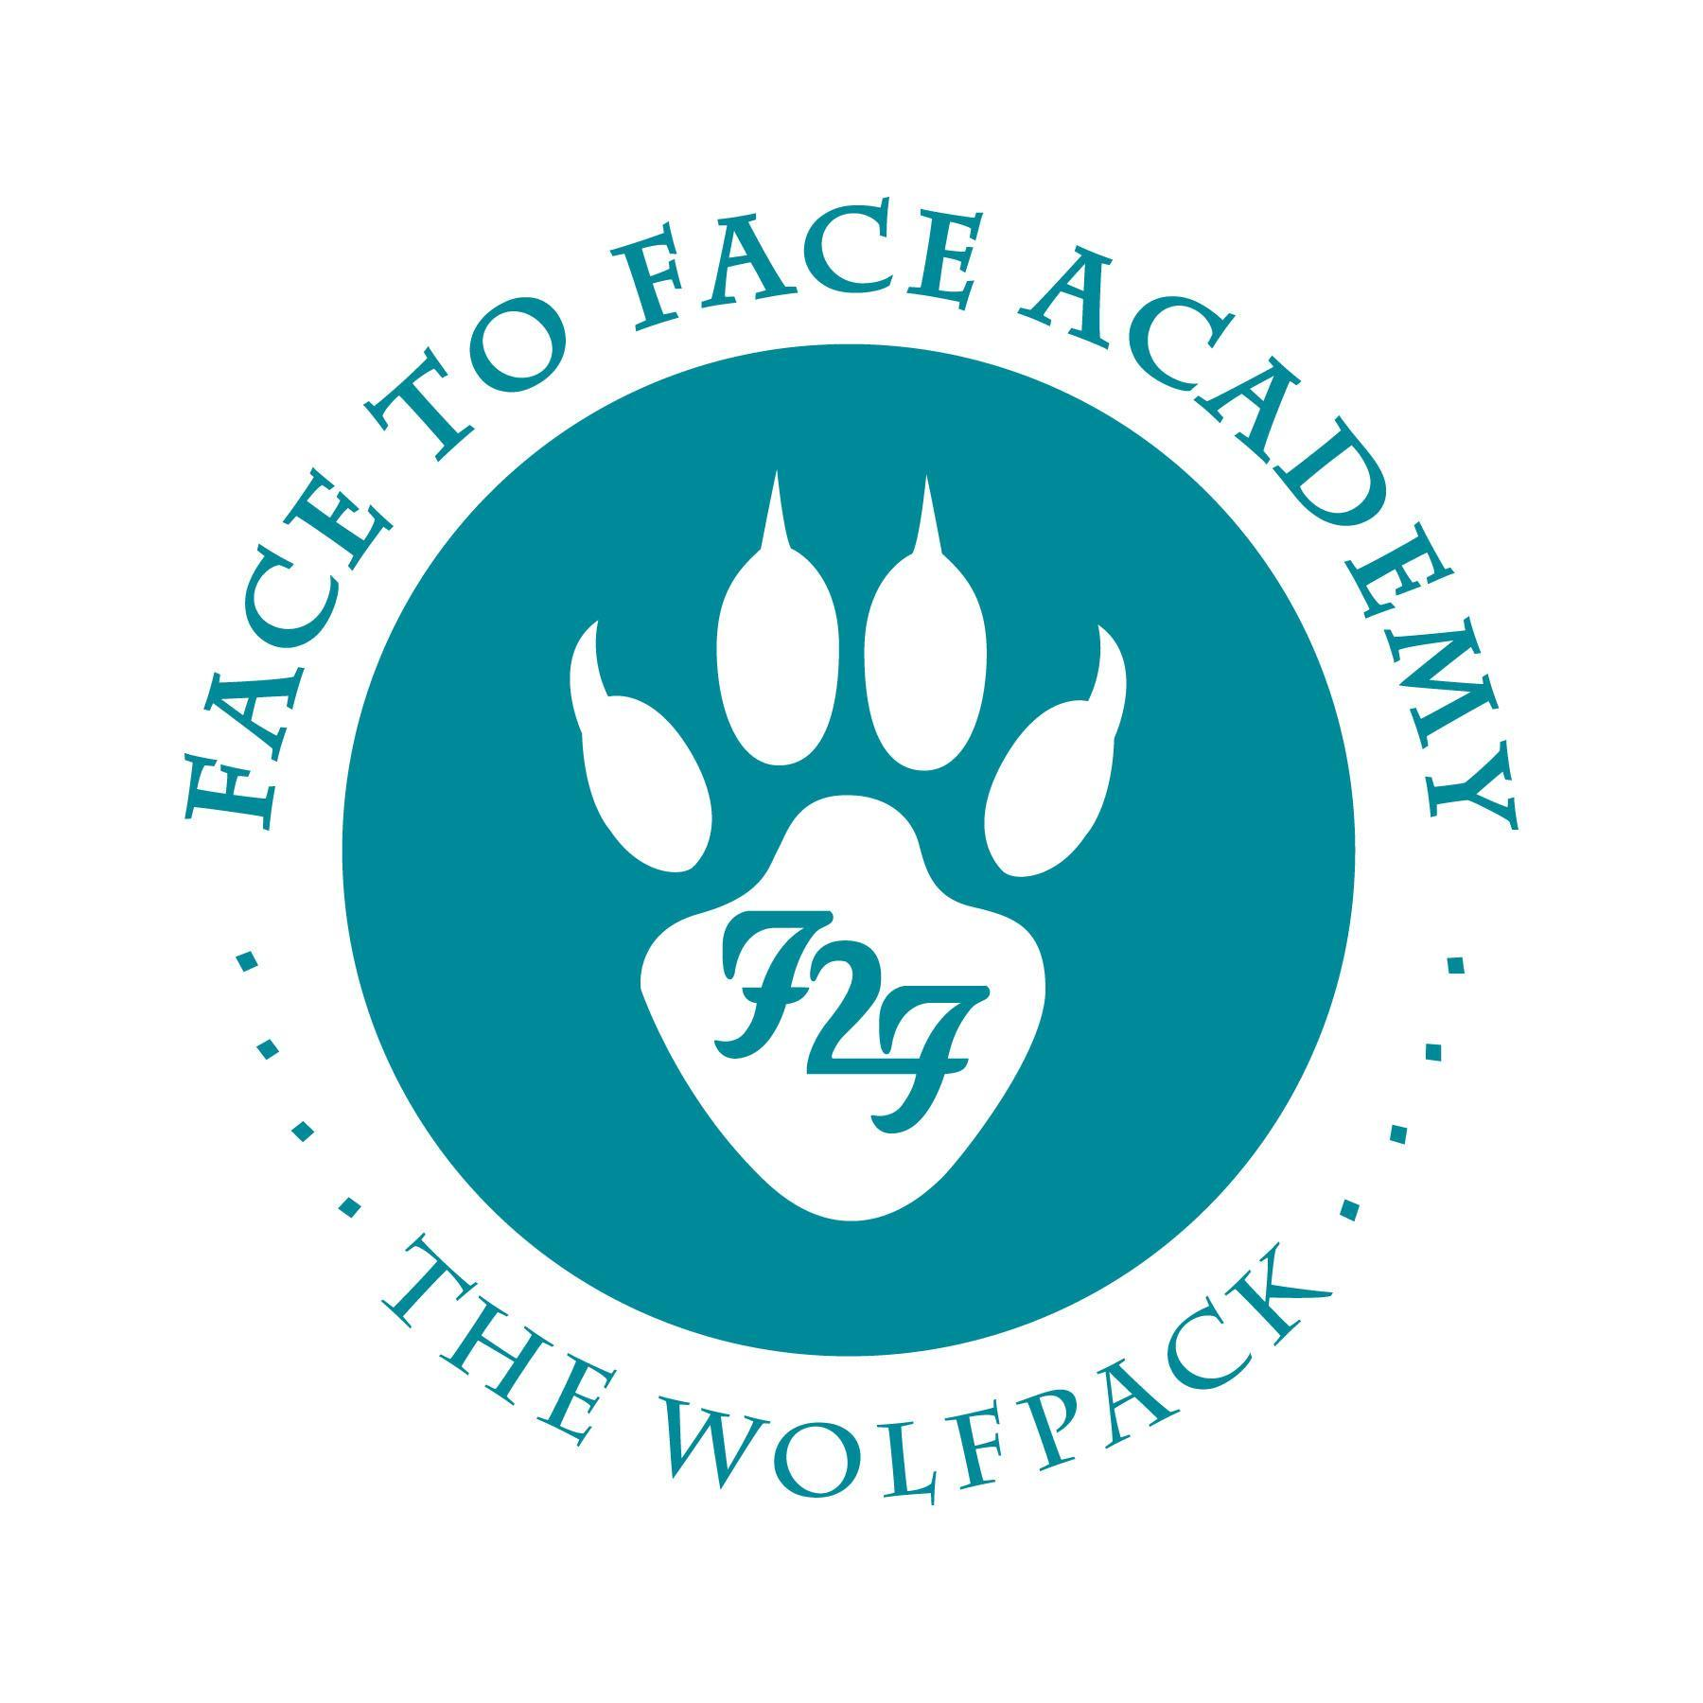
Face to Face Academy

Board Meeting Notes

September 15, 2025

Attendance included Academy School Board Members Bryan Bakke, Jason Meyer, Rachel Samuelson, Mike Nord, and Willie Suttle. Also present for the meeting was Darius Husain (Academy Director,) Jennifer Plum (Ast. to the Board Secretary,) Janel Bitzan ( ) and Joe Aliperto (Deici.) Absent Board Members: Rachel Blawat and Carissa Lange.

This Board Meeting was conducted both on campus and via Zoom so that all attendees could attend.

1) Review of Agenda & Conflict of Interest Regarding Agenda Items
There were no conflicts of interest noted.

2) Public Comment Period
There were no Public Comments made to the Board.

3) SY 25 Financial Audit Report (Creative Planning/Bergan/KDV)

- Ms. Bitzan from Creative Planning/Bergan/KDV presented the SY 2025 independent auditor’s report.
- There were no audit findings for the Academy.
- The Academy’s ADM for SY 25 was 93.86, up from 82.97 the previous school year.
- The Academy’s fund balance was $1,346,161 which is 66.5%, which is also up from 63.4% from last school year. This percentage is higher than other charter schools which is on average 30%.
- The average spending per ADM was $22,269 which is also higher than other charter schools.
- The food service fund, as usual, required a $4,933 transfer from the general revenue.
- Mr. Husain reported that the majority of the fund balance was transferred to the Academy’s ABC to cover the cost of the renovation of the backyard space. He will present a document to describe this process in more detail.
- Mr. Husain thanked both Ms. Bitzan and Mr. Aliperto for their dedicated service to the Academy.

Upon a motion duly made and seconded, the independent auditor's report was accepted as submitted. Approval noted by Mr. Meyer, Ms. Samuelson, Mr. Nord, Mr. Suttle, and Mr. Bakke.

4) Review of August 2025 Board Minutes
*Board Members prefer the protocol of reading the Board Minutes before the meeting.

Upon a motion duly made and seconded, the August 18, 2025 School Board Minutes were accepted as submitted. Approval noted by Mr. Meyer, Ms. Samuelson, Mr. Nord, Mr. Suttle, and Mr. Bakke.

5) Finance Report, Credit Card, Checks, and Wire Statements
- Financial Statements were received through August 31 for the school year 2025/26 and shared for the Board to review.
- Revenue is at 13% received. Revenue is historically lower at this time of the school year.
- Expenditures are 16% spent.
- The school year is 17% complete.
- Reconciled cash balance is $919,039.
- Holdback is noted at $33,116.
- Donations are noted at $2,646.
- The Kinney Family Foundation donation has been received. This is in year-two of the four-year cycle of $20K per school year.
- The budget currently reflects the ADM of 92.50 with the current enrollment at 96/97 students. The Academy is anticipating over 100 students by October 1st.
- September rent and lease operating expenses have been paid.
- Checks and wires, Amazon purchases, and the credit card statements were circulated for the Board members for review.

Upon a motion duly made and seconded, the financial documents were accepted as submitted. Approval noted by Mr. Meyer, Ms. Samuelson, Mr. Nord, Mr. Suttle, and Mr. Bakke.

6) Board Professional Development & First Look: Academy Fund Balance Policy

- Mr. Husain shared the handout “Definition of Fund Balance & Mandatory Fund Balance Policy” for Board Members to review for discussion.
- Review of terms and current numbers were reviewed. Cash-on-hand is $412,564 and the current investment balance is $505,397.
- Review of the assets due to the school.
- Review of what makes the fund balance.
- Mr. Husian shared the most updated fund balance policy from SY 25. The Academy Board revised this policy to reflect a 50-55% fund balance. The fund balance policy is reviewed annually.

7) Academy Program Report

- Academy Board Members should complete the self-assessment and return to Mr. Husain.
- The end of Quarter One (Q1) concludes this week.
- School climate is positive and Q1 hosted many experiential learning activities both on and off campus.
- There is a trip of nine students, two staff members currently in South Dakota for an eight-day trip that includes curriculum on the indigenous history of the area.
- The Academy’s Facebook has been revitalized and shows photos of the recent school events.
- The Academy hosted the largest Annual Meeting at the Fall Festival last week.
- The next Board Meeting is scheduled for October 20, 2025.

Upon a motion duly made and seconded, the meeting adjournment was accepted as submitted. Approval noted by Mr. Meyer, Ms. Samuelson, Mr. Nord, Mr. Suttle, and Mr. Bakke.

Board Meeting adjourned at 5:15 p.m.

Respectfully Submitted,

Rachel Samuelson
Board Secretary

